**AD110: USER INTERFACE DESIGN - Project 3**

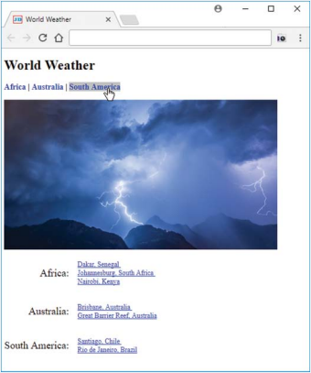

**World Weather**

**Project Description:**

Create a web page named weather.html that mimics the following displayed page, except:

▸ Use a picture different from the one shown.

▸ Use cities different from those shown, continents can be the same or different).

Near the top of the web page, Africa, Australia, and South America are links to their associated areas below the picture. The links have their underlines turned off. When the user’s mouse hovers over one of the links, the background color turns to silver. To implement that effect, use CSS, not JavaScript. In the web page, the user is hovering over the South America link, and that’s why its background is silver and there’s a South America URL at the bottom of the page (the URL appears by default).

Note:

▸ You must include at least three continents. For each continent, you must include at least two links to city weather pages.

▸ Your city weather links must link to working web pages (use a search engine to find such pages).

▸ You must use CSS table properties (not a table element) to position the continent and city names.

Submit your complete summary to **Project 3 in Moodle**.

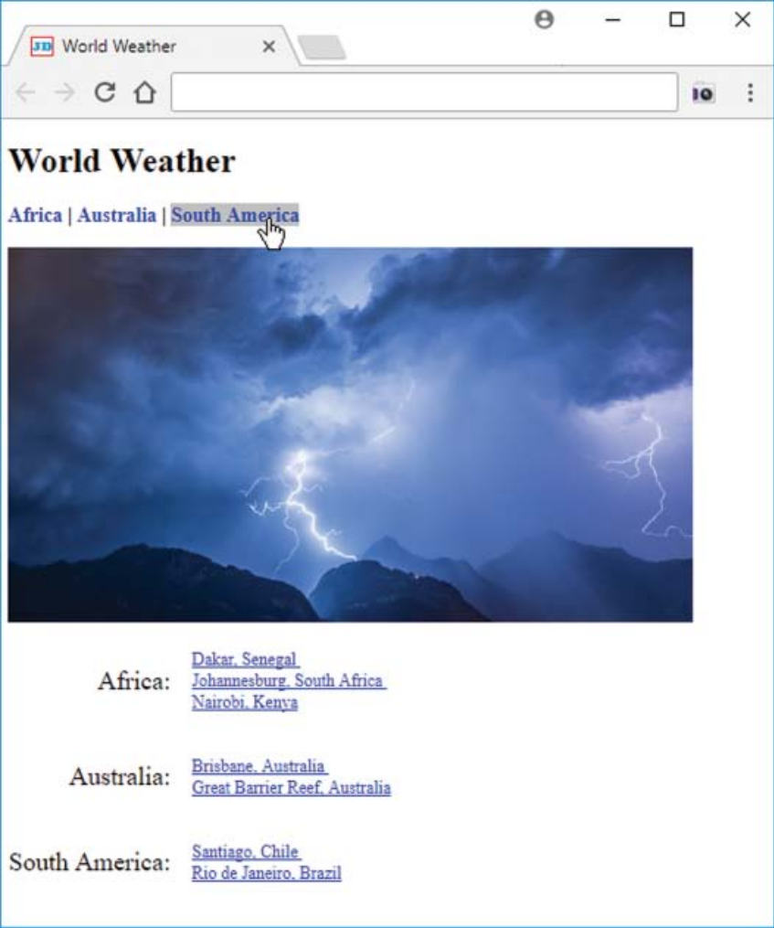

**FOR INSTRUCTOR USE ONLY**

**Grading Rubric**

*Grading accepts a start value of 100. Points will be deducted for failure to fully complete or meet the stated requirements. Grading: 90-100 = Represents work of superior quality (A); 80-89 = Represents work of good to very good quality (B); 70-79 = Represents adequate command of class content (C); 69 and below = Represents work that shows a need for development or improvement (F); 0 = Represents plagiarized work (F).*

**AD110: USER INTERFACE DESIGN (NCP-WEB)**

**Student:**

**Instructor:**

**Date:**

**Project 3**

|  |  |  |
| --- | --- | --- |
| **Description of requirements** | **Possible Points** | **Your Points** |
| Create a web page named weather.html | **20** |  |
| Use a picture different from the one shown | **15** |  |
| Use cities different from those shown, continents can be the same or different) | **15** |  |
| You must include at least three continents. For each continent, you must include at least two links to city weather pages. | **15** |  |
| Your city weather links must link to working web pages (use a search engine to find such pages) | **15** |  |
| You must use CSS table properties (not a table element) to position the continent and city names | **20** |  |
| **TOTAL** | **100** |  |

**YOUR SCORE**: ________

**Instructor Comments:**